**FUNCTIONS:**

**Mapping function:**

In Python, "maps" are commonly referred to as dictionaries. They consist of key-value pairs for efficient data retrieval and storage.

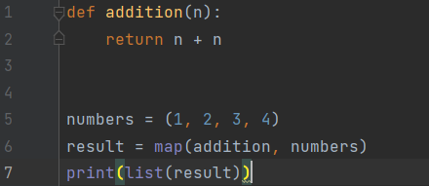

**Output:**



**String Function:**

We can perform many operations using some string functions.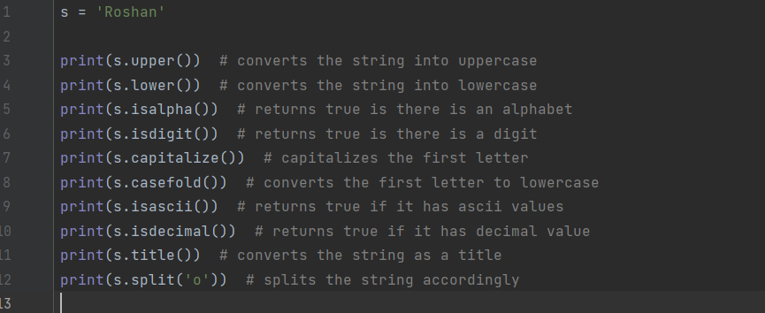

**Output:**

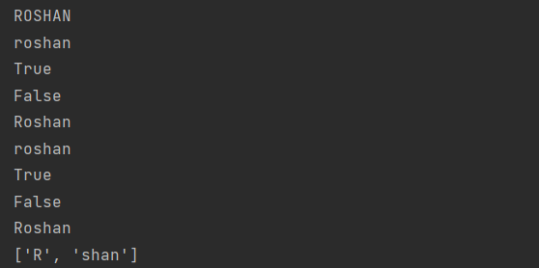

**Number Function:**

Here are some number functions.

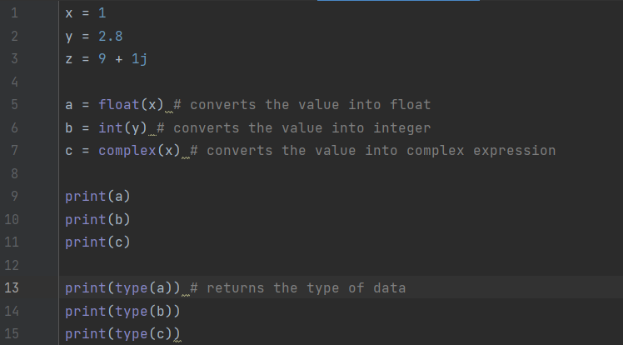

**Output:**

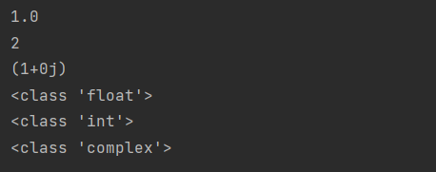

**Date and Time function:**

A date in Python is not a data type of its own, but we can import a module named datetime to work with dates as date objects.

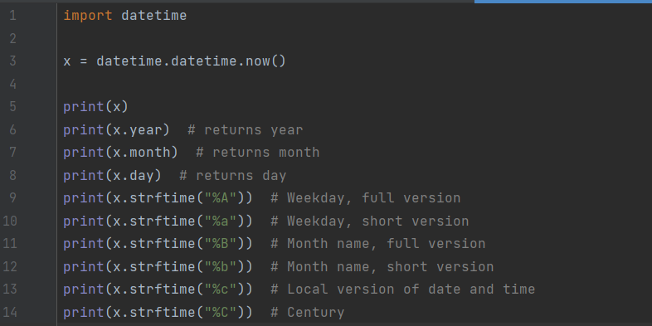

**Output:**

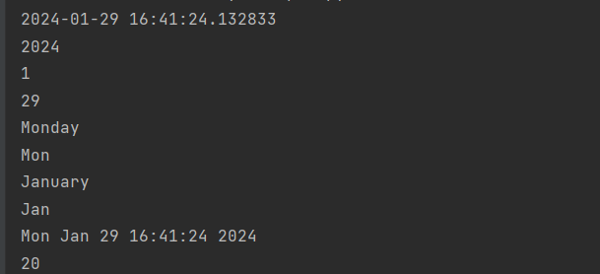

**Python function:**

Modular block of code. Defined with def. Takes input, performs tasks, and optionally returns a result.

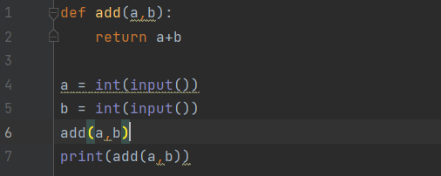

**Output:**

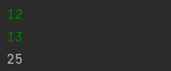

**Default argument values:**

Function parameters with default values. If not provided during the function call, defaults are used.

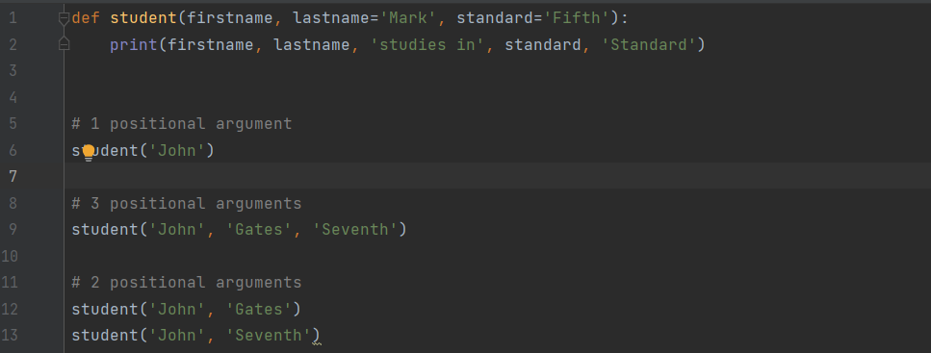

**Output:**

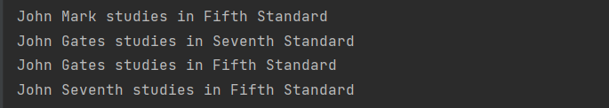

**Keyword Arguments:**

Function arguments identified by parameter names are keyword arguments.

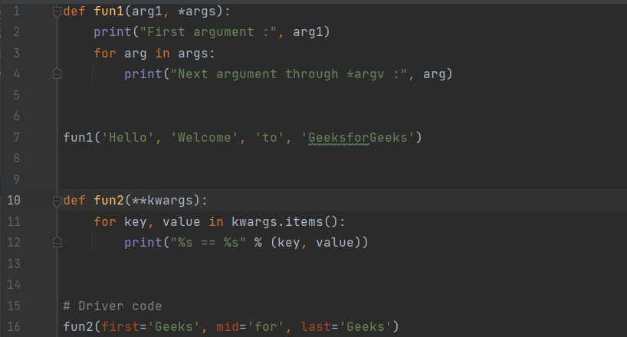

**Output:**

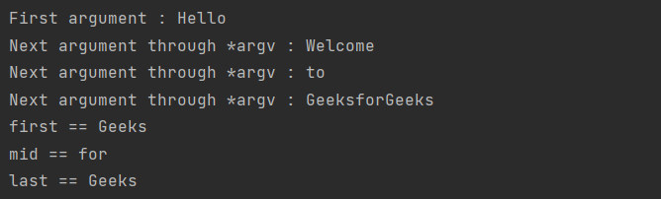

**Arbitrary argument lists:**

Function parameter that allows passing variable number of arguments. Defined using *args.

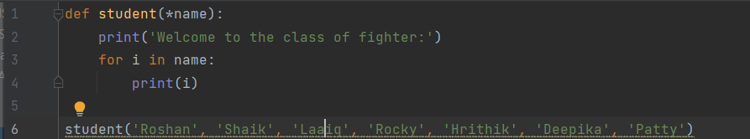

**Output:**

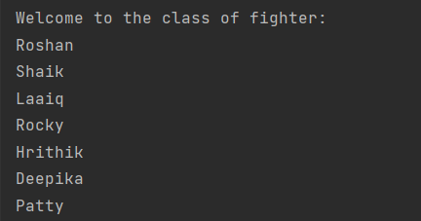

**Lambda expressions:**

Anonymous functions. Defined with lambda. Often used for short, one-time operations.

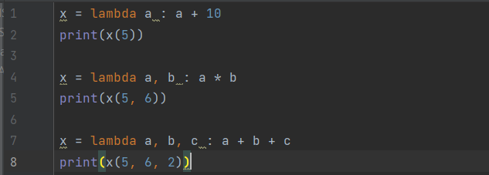

**Output:**

